OTHER COLLECTIONS

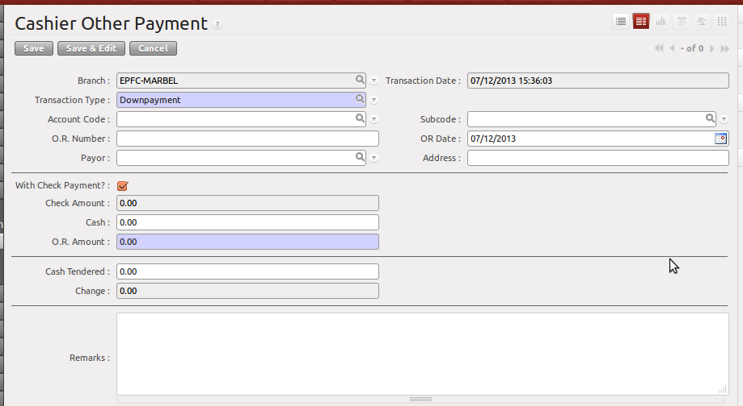
Currently Defined Transaction Types:
    - Downpayment
    - Pre-Termination Processing Fee
    - Change Term Processing Fee
    - Others

After selection of Transaction Type, the account code will be automatically filled-up if it is already configured by the person in-charge. If it returns nothing, you should manually fill-up the Account Code and the Subcode.

Check Information
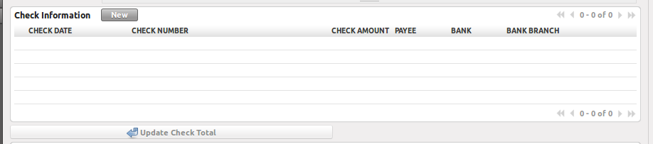
    - This will only appear if “With Check Payment” is checked.

Step 1 → Click New Button
Step 2 → Input check Details
Step 3 → Click Save Icon (diskette icon)
Step 4 → Click “Update Check Total”
Multiple Details in One (1) Official Receipt
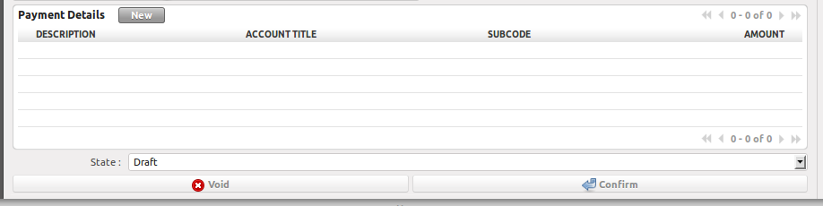
This will only appear if Account Code is “blank”.

Validations:
- Will not proceed saving if Processing Fee for Pretermination/Change Term is not configured.
- Will not proceed saving if OR amount is less than the configured processing fees.
- Will not void transaction if Void Date is not equal to Transaction Date.

